# Lab 4 – SID, PowerShell

# Task 1: Getting SID, SAT on Windows

* Obtain the SID of the current login with **WMIC** command. Attach a screenshot for the SID and highlight it in red/yellow.

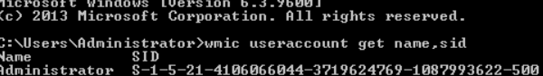

I CANT HIGHLIGHT THAT ON THE CMD

* Obtain the SID of the current login in the Registry. Attach a screenshot for the SID and highlight it in red/yellow.

# Task 2: Getting SID on SQL Server

Get the SID of the account you used for SQL Server login.

A. SID: ____________________________________________.



B. What is the role of the function “fn_SIDToString” in the above?

The function fn_SIDToString converts a binary Security Identifier (SID) into a human-readable string format (e.g., "S-1-5-21-..."). This makes SIDs easier to interpret and use in contexts like the Windows Registry or system logs, improving readability and usability for administrators or scripts. It allows binary SIDs to be displayed as strings, making them more accessible for interaction.

C. Compare the SID from SQL Server for the administrator login with that from Windows Server for the administrator. Show the two screenshots. Use the SIDs in a string format (that is, in the S- format, not in Hex). Are they the same?

The SID of the administrator login from SQL Server (show the S-format)



The SID of the administrator login from Windows Server (show the S-format)



D. SID: .

E. SID: .

F. Are the SIDs of login SIDTest the same? Describe the reason why they are (not) the same?

They aren’t the same because the hexadecimals don’t overall match up

# Task 3: Learn PowerShell Scripting

* Run your script and report the output in a screenshot.

